Reference/Protocol | NA

INDEX

TABLE OF CONTENTS

1.0 OBJECTIVE AND SCOPE: 4
2.0 BACKGROUND: 4
3.0 DETAILS OF PROCEDURE: 4
4.0 RESULTS, DISCUSSION, CONCLUSION AND RECOMMEDATION: 7
4.1 ASSESSEMENT APPROACH: 7
5.0 ANNEXURES: 24
6.0 REFERENCES: 24
7.0 ENCLOSURES 24
8.0 CHANGE HISTORY 24

LIST OF TABLES

Table 1: Materials and reagents used for method development 4
Table 2: List of Instrument and Equipment’s 5
Table 3: List of Consumables 5
Table 4: Samples used for the development study 6
Table 5: Method parameters for initial method development. 6
Table 6: Obtained repeatability data with three mobile phase blank injections between the samples. 8
Table 7: System suitability values obtained during repeatability experiment (Co-Qualification Run at PD) 11
Table 8: System suitability summary obtained during repeatability experiment (co-Qualification Run at PD) 12
Table 9: Compiled data for ARC101 repeatability experiment (co-Qualification Run at PD) 12
Table 10: System suitability values obtained during repeatability experiment (co-Qualification Run at QC) 15
Table 11: System suitability summary obtained during repeatability experiment (co-Qualification Run at QC) 15
Table 12: Compiled data for ARC101 repeatability experiment (co-Qualification Run at QC) 16
Table 13: Overall Intermediate precision Compiled data for ARC101 repeatability experiment (MDQR, co-Qualification Run at PD and QC) 16
Table 14: compiled System suitability data experiment PS80 Peak assessment 17
Table 15: compiled purity data experiment PS80 Peak assessment 17
Table 16: SST Data PD Development data ARC system:(PS80 Peak) –Repeatability 20
Table 17: Compiled purity data PD Development data ARC system:(PS80 Peak) –Repeatability 20

LIST OF FIGURE

Figure 1:Overlaid chromatogram of ARC101 DP Repeatability (Excipient carry over check with Three MP Wash with tween trap column 70µL load 8
Figure 2:Development data from PD-Data from the finalized method Repeatability-Injection 1 9
Figure 3:Development data from PD-Data from the finalized method Repeatability-Injection 2 9
Figure 4:Development data from PD-Data from the finalized method Repeatability-Injection 3 10
Figure 5:Development data from PD-Data from the finalized method Repeatability-Injection 4 Zoom 10
Figure 6: Overlay of repeatability Co-qualification PD run 13
Figure 7:Co-Qualification data from PD-Repeatability-Injection 1 13
Figure 8:Co-Qualification data from PD-Repeatability-Injection 2 14
Figure 9:Co-Qualification data from PD-Repeatability-Injection 3 14
Figure 10:Overlaid chromatogram Development data from PD-Repeatability-Injection 18
Figure 11: Development data from PD-Repeatability-Injection 1 19
Figure 12: Development data from PD-Repeatability-Injection 2 19
Figure 13: Development data from PD-Repeatability-Injection 3 20
Figure 14: PD Development data ARC system:(PS80 Peak) –Injection 1 22
Figure 15: PD Development data ARC system:(PS80 Peak) –Injection 2 22
Figure 16: PD Development data ARC system:(PS80 Peak) –Injection 3 22
Figure 17: Chromatogram with peak labelling for 1mg DP SEC-HPLC 24

LIST OF ABBREVIATIONS

2D | 2 Dimensional
AD | Analytical Development
CD3
CLDN6 | Claudin-6
DP | Drug Product
HMW | High Molecular Weight
IgG1 | Immunoglobulin G
IRS | Internal Reference standard
MDQR | Method Development Qualification Report
MP | Mobile Phase
MQ | Method Qualification
NSCLC | Non-Small Cell Lung Cancer
PD | Product Development
PDA | Photo Diode Array
PS80 | Polysorbate 80
QC | Quality Control
RP | Report
RSD | Relative Standard Deviation
SEC-HPLC | Size Exclusion Chromatography -High Performance Liquid Chromatography
SST | System Suitability

- OBJECTIVE AND SCOPE:
The objective of this document is to provide a data summary of the impurity peak assessment, specifically the excipient peak (PS80), which is detected within the high molecular weight retention time window using SEC-HPLC techniques. This includes the method development of SEC-HPLC for the separation of size variants, particularly high molecular weight (HMW) species, present in BYSN101-1mg DP Presentation samples via size exclusion high-performance liquid chromatography (SEC-HPLC).
The document details the specifics of the method development process and the outcomes obtained in the study that concentrated on the identification and labeling of the impurity (excipient peak) through SEC-HPLC methodologies.
- BACKGROUND:
BYSN101 is an IgG1 bispecific antibody (Knob & Hole) with anti CD3 arm & anti-CLDN6 arm. Anti-CD3 arm binds to CD3 receptor on T-Cells triggering their activation and proliferation, and enhancing their cytotoxic functions, where as anti-CLDN6 arm binds to CLDN6 Receptor which is often overexpressed in various cancers. Molecules with anti-CD3 & anti-CLDN6 arm are primarily used in the treatment of Ovarian Cancer, Non-Small Cell Lung Cancer (NSCLC), Testicle cancer, Endometrial Cancer & other solid tumors. BYSN101 DS and DP is manufactured by Dr. Reddy’s Laboratories Ltd. (DRL).
The purpose of the assessment of peak characterization using the ARC101 1mg SEC-HPLC method is to ensure the precise identification and quantification of significant impurities, rather than the quantification of non-proteinaceous or micellar excipients, thereby achieving consistency in the results
- DETAILS OF PROCEDURE:
- Materials and reagents:
Table 1: Materials and reagents used for method development
Sr. No. | Chemical Name | Catalogue Number | Lot Number | Manufacturer
1 | Sodium Phosphate Dibasic Dihydrate​ (Na₂HPO₄.2H₂O​) | 71645-1KG | BCCJ9064 | Sigma-Aldrich
2 | L-Arginine HCL | A0528 | QDBTIHH | TCI
3 | Sodium Chloride (NaCl) | 1.93606.0521 | ML2M722272 | Merck
4 | Hydrochloric acid | 1.93401.0521 | DJ1D711201 | Merck

- List of Equipment:
Table 2: List of Instrument and Equipment’s
Sr. No. | Equipment | Make | Instrument ID
1 | Analytical Weighing Balance | RADWAG and Sartorius | REL2-WB-05  REL2-WB-01
2 | pH meter | Thermo Scientific | REL2-CM-01
3 | Sonicator | Spectralab | REL2-AD-UW-01
4 | Magnetic stirrer | IKA REO basic C) | REL2-AD-MR-03
5 | HPLC with PDA detector | Waters | REL2-AD-HL-40  REL2-AD-HL-37  REL2-AD-HL-31
6 | Vacuum pump | Millipore | REL2-AD-VP-03
- List of Consumables:
Table 3: List of Consumables
Sr. No. | Equipment | Make | Instrument ID
1 | Column TSKgel G3000SWxL 7.8 mm I.D x 30 cm, 5 µm | TOSOH | C920004974/0765, C920004974/0763,  C920004974/0750
2 | Membrane filter: 0.2 µm 47mm PES | Millipore | NA
3 | Tween trap-NP- 010054-4603 | Sepax Technologies | NA
- System suitability standard/reference standard:
BY-IRS1, which were developed during USP and DSP process optimization, were used for the development study.
- Details of samples:
Samples used during the entire study of development are listed in Table 3.
Table 4: Samples used for the development study
Sr. No. | Sample ID | Sample Type | Batch details
1 | BY-IRS1 | IRS | BY-IRS1
2 | BYVCF017-1m DP | DP | BYVCF017
3 | BYVCL020-Formulation Buffer | Diluent | BYVCL020
- Mobile phase details: (50mM PB, 0.2M L-Arginine HCL & 150mM NaCl pH 7.5±0.2):
- Method details:
The following HPLC conditions were employed for method development and co-qualification data.
Table 5: Method parameters for initial method development.
Parameters | Condition
Run time | 20 min
Flow rate | 1.0 mL/ min
Detection wavelength | 280 nm
Column temperature | 25 ± 2 °C
Sample temperature | 2-8 °C
Gradient conditions | Isocratic
On-column protein load | 14 µg equivalent
Mobile Phase | 50mM PB, 150mM NaCl, & 0.2M L-Arg HCL, (pH 7.5±0.2)

- RESULTS, DISCUSSION, CONCLUSION AND RECOMMEDATION:
All the reagents, chromatographic conditions, sample preparation, gradient conditions, system suitability acceptance criteria and data analysis were performed as per the available existing method, considered the literature & basic principle of size exclusion chromatography.

ASSESSEMENT APPROACH:
The purity method for the presentation of ARC101 1mg DP has been developed and finalized (MDQR report: BY-RP-00071), utilizing the Tween trap attached to the main column to minimize the level of the excipient, specifically PS80. As a result, the excipient has been significantly removed from the sample. A post-finalization method has been proposed for transfer through a co-qualification approach (Protocol no BY-PR-00026). During the execution of the co-qualification, high molecular weights (HMWs) exhibited the greatest variation, with a %RSD exceeding 40%. This variation is likely attributed to HMW1 and may also be affected by the binding of excipients with the guard column peak. Therefore, to understand the peak profile by comparing it with PDA spectral data an assessment has been conducted by providing the spectral data for the developments and the co-qualification run in the subsequent sections.
- Development data from PD:
- Data from the finalized method (Tween trap column and 3 blank injections between sample)- 2D Channel at 280nm.
Compiled Data from method development finalized method depicted below with observed cumulative variation in between high molecular weight species and the monomer species (Reference report BY-RP-00071)
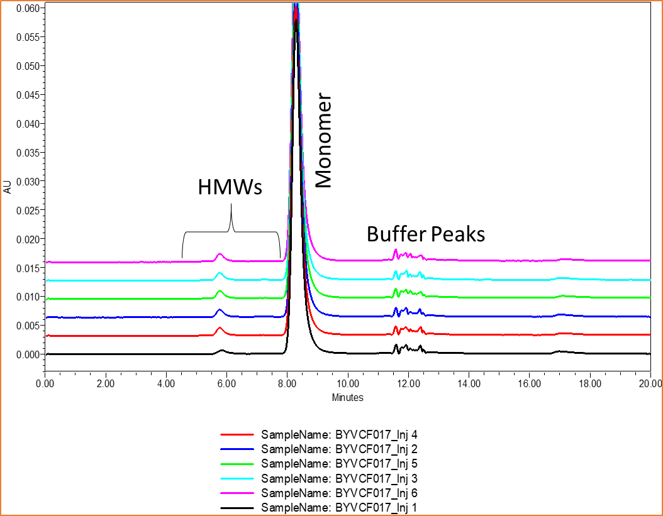
Reference ELN: BY-AD-24-MD-00-76
Figure 1:Overlaid chromatogram of ARC101 DP Repeatability (Excipient carry over check with Three MP Wash with tween trap column 70µL load
Table 6: Obtained repeatability data with three mobile phase blank injections between the samples.
Sr. No. | Injection No | HMW 1 | HMW 2 | Total HMW | Monomer
1 | BY_IRS1_SST1_0.2 mg/mL in FB | 0.2 | 0.3 | 0.5 | 99.5
2 | BY_IRS1_SST2_0.2 mg/mL in FB | 0.18 | 0.42 | 0.6 | 99.41
3 | BYVCF017_Inj1 | 1.32 | 0.23 | 1.55 | 98.45
4 | BYVCF017_Inj2 | 2.10 | 0.23 | 2.33 | 97.67
5 | BYVCF017_Inj3 | 2.18 | 0.23 | 2.41 | 97.59
6 | BYVCF017_Inj4 | 2.28 | 0.20 | 2.48 | 97.52
7 | BYVCF017_Inj5 | 2.31 | 0.26 | 2.57 | 97.42
8 | BYVCF017_Inj6 | 2.52 | 0.22 | 2.74 | 97.26
9 | Average |  |  | 2.35 | 97.65
10 | Standard deviation |  |  | 0.42 | 0.42
11 | %RSD |  |  | 17.69 | 0.43
12 | BY_IRS1_Flank_0.2 mg/mL in FB | 1.1 | 0.31 | 1.41 | 98.60
Reference ELN: BY-AD-24-MD-00-75
Note: % area Data used from the integration without the blank subtraction procedure.

- Data from the finalized method (Tween trap column and 3 blank injections between sample)- PDA Spectral analysis.
- Following are the extracted chromatogram PDA spectrum data.
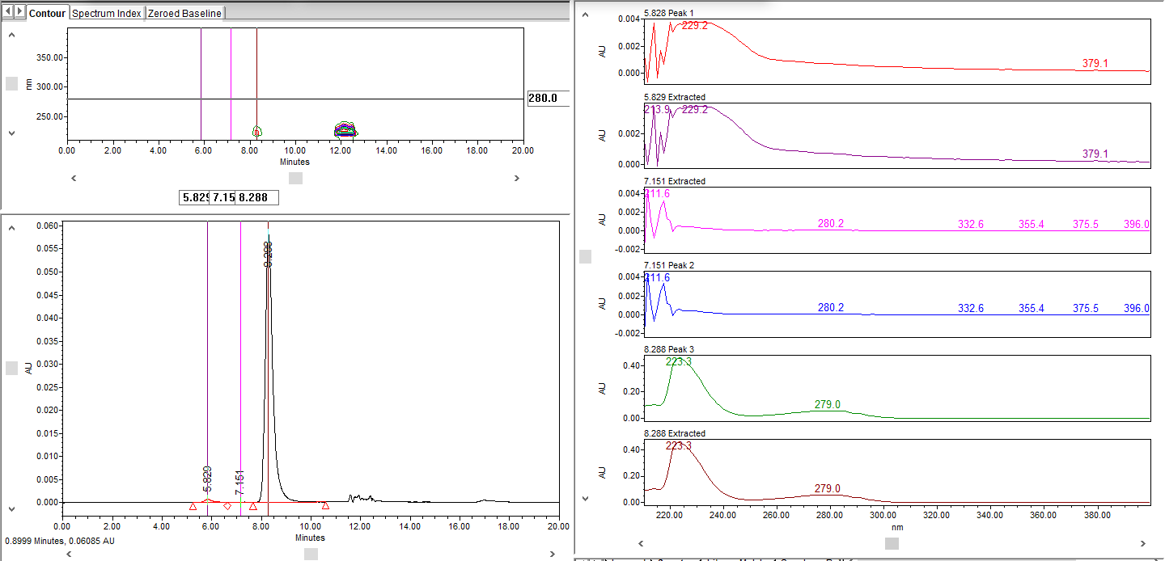
Reference ELN:
Figure 2:Development data from PD-Data from the finalized method Repeatability-Injection 1

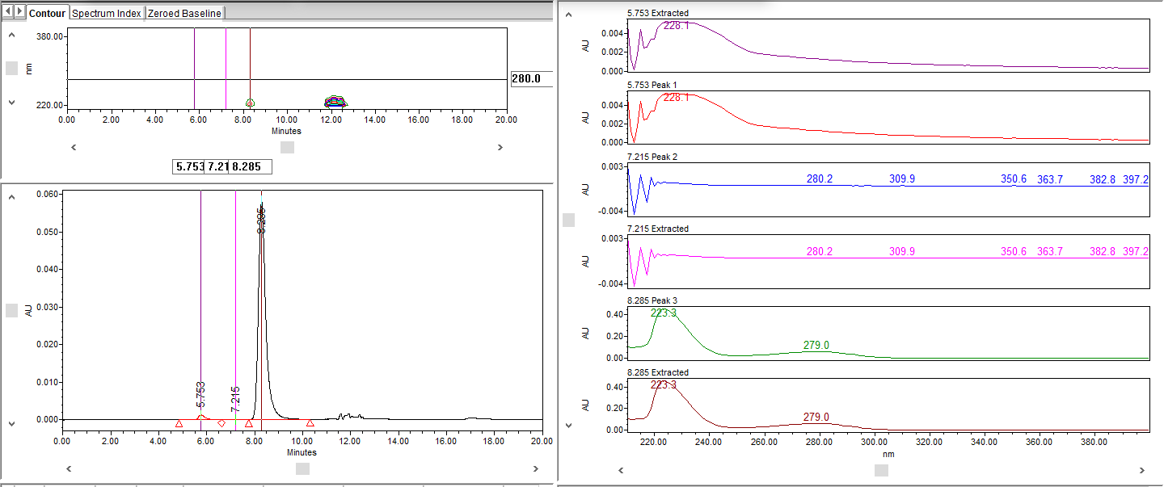
Reference ELN:
Figure 3:Development data from PD-Data from the finalized method Repeatability-Injection 2

